Anomalous temperature and seasonality of natural mortality

Overview
The relationship between daily temperature and deaths from natural causes (i.e., excluding injuries) is well-established, especially for cardiorespiratory diseases.^{2–7,125} There is however limited analysis on how monthly deviations of temperature from long-term norms will impact deaths in a consistent way across different causes of natural death, demographic subgroups of the population and over space.
Using data on deaths from natural causes and temperature over a 37-year period (1980-2016) in the entire contiguous United States (see Chapter 3), I formulated a Bayesian spatio-temporal model (see Chapter 5) to estimate how anomalous temperatures affect deaths from a mutually exclusive and collectively exhaustive set of cardiovascular and respiratory diseases as well as cancers, by age group and sex. I found that a 1°C anomalously warm year would be associated with an estimated 4,369 (95% credible interval 4,024, 4,706) fewer cardiorespiratory deaths in the contiguous United States, 0.4% of total cardiorespiratory deaths in 2016. The reduction in deaths would be concentrated in those 55 years and over, and would decrease in all but summer months. The greatest percentage reduction for cardiorespiratory deaths in January would be in Louisiana (-1.5% (-1.2%, -1.9%)) for males and Washington (-1.3% (-1.0%, -1.7%)) for females. The greatest percentage increase in cardiorespiratory deaths in July would be in New Mexico (1.1% (0.5%, 1.7%)) for males and Utah (1.2% (0.6%, 1.7%)) for females. Deaths from cancers show no association with anomalous temperature. The findings indicate that as temperatures increase, the overall number of deaths from cardiorespiratory diseases will decrease in older age groups, but will remain a significant burden in the United States.

Introduction
There are well-established associations between daily temperature and deaths from some natural causes, mainly cardiorespiratory diseases.^{2–7,125} Cardiorespiratory diseases made up 40% of all deaths in the United States in 2016 and therefore remain significant to public health policy and planning (see Section 3.2.7). As cold weather is linked to increased stress on the circulatory system as well as decreased immune system capability,^{98,130} some studies predict a decrease in cardiorespiratory disease deaths in winter months due to higher temperatures expected as the climate changes.^{78–80,105} Others argue that this may not be true due to a weakening association of excess winter mortality with temperature,^{266,267} though methods in these studies have been criticised as negating seasonal biases and therefore coming to an incorrect conclusion.^{80,81} Deaths from cancers also make up a considerable proportion of deaths in the United States (23% of all deaths in 2016) (see Section 3.2.7). However, only a few studies have examined an association between temperature and deaths from cancers,^{123,137–140} though seasonality in cancer death rates exists for older age groups.³⁸ My aim was to evaluate how deaths from various chronic diseases, including deaths from cardiorespiratory disease and cancers, may be affected by changes in temperature that could arise in the United States as a result of global climate change.

Data
Full details of the data processing choices I made can be found in Chapter 3. Here, I used vital registration data on all 79,689,529 natural deaths in the contiguous United States from 1980 to 2016 along with population records to calculate monthly death rates for each type of natural death, age group, sex and state combination. Of this, 41,105,009 (52%) were deaths from cardiorespiratory diseases and 19,862,760 (25%) were deaths from cancers. For each cardiorespiratory death, I mapped each ICD-9 and ICD-10 code to three cardiovascular (ischaemic heart disease, cerebrovascular disease, other cardiovascular diseases) and three respiratory (chronic obstructive pulmonary disease (COPD), respiratory infections, other respiratory infections) types of cardiorespiratory deaths (Table 11). Other cardiovascular diseases included rheumatic, hypertensive and inflammatory heart diseases. Other respiratory diseases included asthma and otitis media. I did not further subdivide cancer deaths because [[[evidence on being temp related / hypothesised pathways]]]. The remainder of deaths were from causes other than cancers, cardiorespiratory diseases and injuries, described in more detail in Section 3.2.7. The composition of this group of causes of death varied by age group and sex. Therefore, I did not include them in …. I obtained monthly population-weighted temperature from ERA-Interim.²⁰⁹

Chronic disease | ICD-9 | ICD-10
Cardiorespiratory | 381-382, 390-519 | H65-H66, I00-J99
Cardiovascular diseases | 390-459 | I00-I99
Ischaemic heart disease | 410-414 | I20-I25
Cerebrovascular disease | 430-438 | I60-I69
Other cardiovascular diseases | 390-409, 415-429, 439-459 | I00-I19, I26-I59, I70-I99
Respiratory diseases | 381-382, 460-519 | H65-H66, J00-J99
COPD | 490-492, 495-496 | J40-J44
Respiratory infections | 381-382, 460-466, 480-487 | J00-J6, J9-J18, J20-J22
Other respiratory diseases | 467-479, 488-489, 493-494, 497-519 | H65-H66, J7-J8, J19, J23-J39, J45-J99
Cancers | 140-239 | C00-C99, D00-D48
Table 11. Chronic disease groups used in the analysis with ICD-9 and ICD-10 codes.

Statistical methods
I analysed the association of monthly death rates with anomalous temperature using a Bayesian spatio-temporal model, fully described in Chapter 5 and described in brief in Section 6.4. I used the resultant risk estimates (Figure 52-Figure 57) to calculate additional deaths if each month in each state were +1°C above its long-term norm, an equivalent calculation of Section 6.4. I found no association between proportional change in deaths for cancers and anomalous temperature (Figure 58). I therefore did not include the results in further calculations.
I also ran a model where each state was given a separate temperature anomaly coefficient to examine spatial variation in percentage change in deaths if each month in each state were +1°C above its long-term norm (Equation 9 in Chapter 5), In this model, I used all cardiorespiratory diseases together as my dataset, as small number issue arose when breaking down deaths by type of cardiorespiratory disease, age group, sex and state.
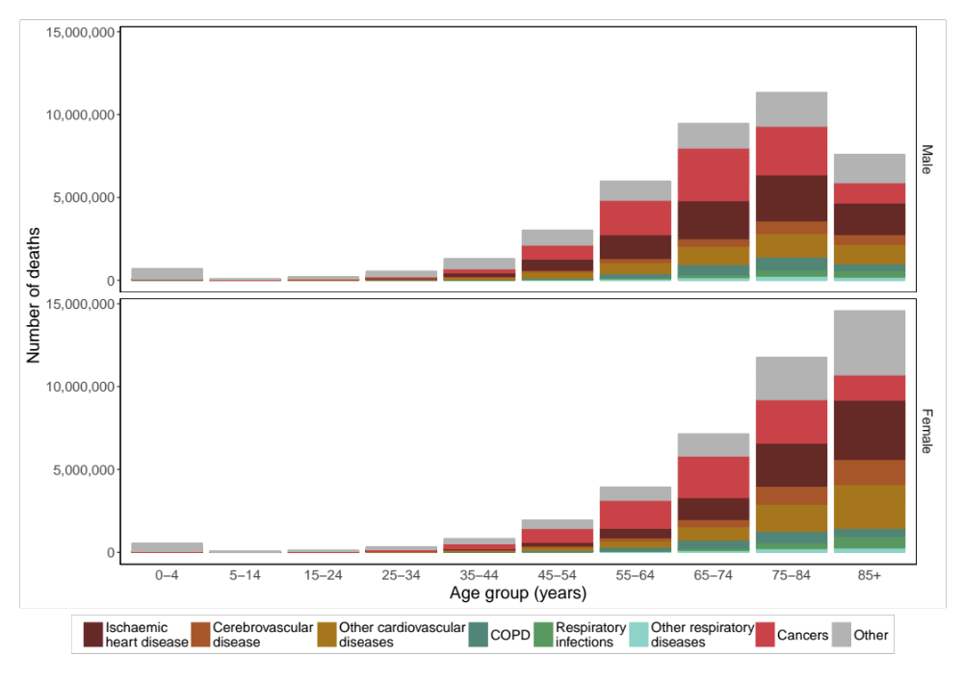
Figure 46. Number of deaths by natural cause, sex and age group in the contiguous United States for 1980-2016.

Results
From1980 to 201620,070,797 boys and men and 21,034,212 girls and women died from cardiorespiratory diseases in the contiguous United States . These deaths accounted for 46.3% and 49.9% of all male and female deaths respectively (Figure 2 in Chapter 3). 77.1% of male cardiorespiratory disease deaths and 88.7% of female cardiorespiratory disease deaths were in those aged 65 years and over (Figure 46). For females, 42.7% of cardiorespiratory disease deaths were in those aged 85 years and over (Figure 46).
Ischaemic heart disease (IHD) accounted for 45.3% of cardiorespiratory disease deaths in males and 38.7% in females (Figure 46). Men 25 years and older and women 35 years and above died from ischaemic heart disease more than any other cardiorespiratory disease. Below 25 years of age, respiratory infections were the largest single cause of cardiorespiratory disease death in both males and females (Figure 46).
As seen in Chapter 4, there has been a constant seasonality over time in cardiorespiratory deaths for most age groups in both sexes (Figure 17 and Figure 18). For each of the six types of cardiorespiratory disease death, there were more total deaths in the winter than in the summer (Figure 47).
There was a decline in age-standardised death rates of four out of six types of cardiorespiratory disease (ischaemic heart disease, cerebrovascular disease and respiratory infections) for both men and women from 1980 to 2016. The largest decline over time was for ischaemic heart disease deaths, which declined by over 50% for both men and women from 1980 to 2016 (Figure 48), driving the overall reduction in cardiorespiratory deaths (Figure 2 in Chapter 3). COPD deaths in males, while increasing from the 1980s until the late 1990s, have steadily decreased since then. This contrasts with COPD death rates of females, which have been increasing since the 1980s (Figure 48). Age-standardised death rates from other respiratory diseases have also increased over the time period (Figure 48). There is a discontinuity in age-standardised death rates in other cardiovascular diseases due to the change from the ICD-9 to ICD-10 coding in the United States in 1999, when some deaths in this group were assigned to ischaemic heart disease (Figure 48).
The number of cancer deahts was … 10,428,202 boys and men and 9,434,558 girls and women died in the contiguous United States (Figure 2 in Chapter 3). There were slightly more deaths from cancers in winter than in summer (Figure 47), which explains the seasonality in cancer deaths that was evident in those 55 years and older (Figure 15 and Figure 16 in Chapter 4). Further details of cancer deaths can be found in Section 3.2.7. Death rates from cancers have decreased over time (Figure 48).
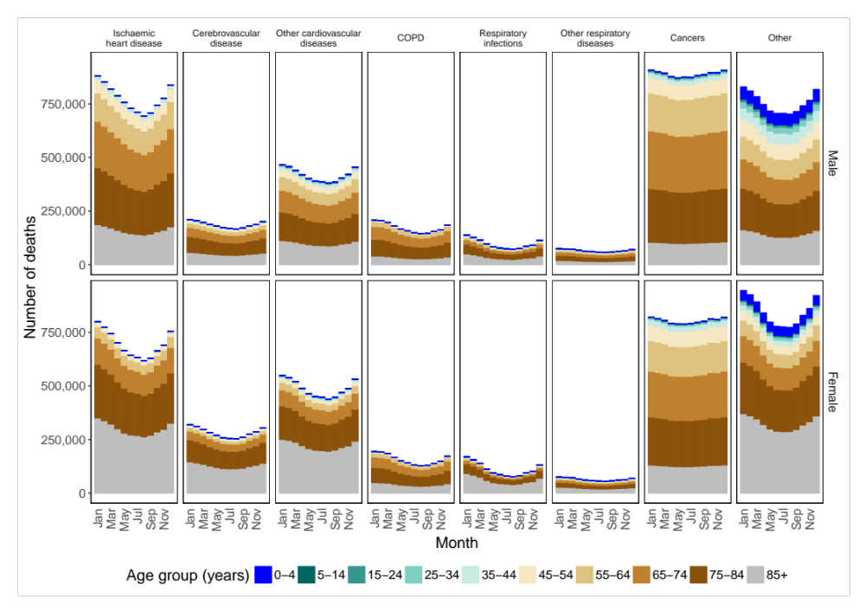
Figure 47. Number of deaths by natural cause, month, sex and age group in the contiguous United States for 1980-2016.
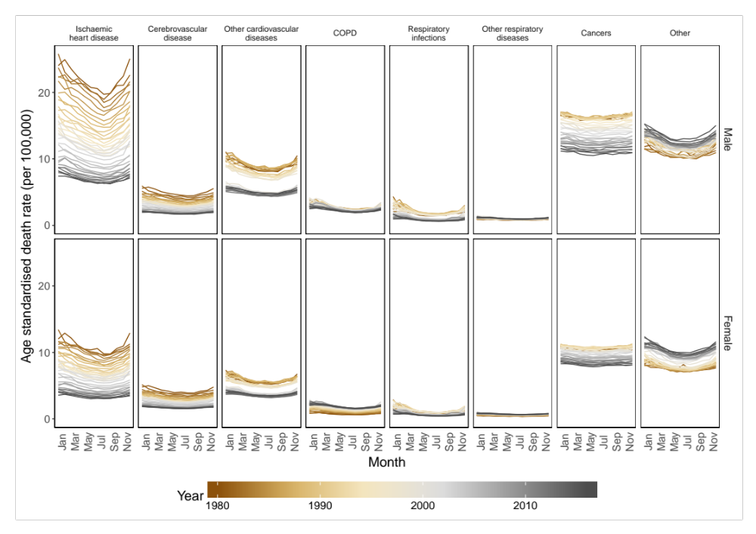
Figure 48. National age-standardised death rates from 1980 to 2016, by sex, cardiorespiratory disease and month

[[[start from rate ratios here, which are output of model. then to deaths]]]
I estimated that there would be 4,369 (4,024, 4,706) fewer cardiorespiratory disease deaths, equivalent to 0.4% of all cardiorespiratory deaths in 2016, in a year in which each month in each state were +1°C above its long-term norm (Figure 49). Deaths from all cardiovascular diseases (ischaemic heart disease, cerebrovascular disease and other cardiovascular diseases) and respiratory disease (COPD, respiratory infections and other respiratory diseases) would be predicted to decrease (Figure 49). The biggest reduction of deaths would be from ischaemic heart disease (1,883 (1,706, 2,058)) followed by other cardiovascular diseases (1,039 (835, 1,243)). 55% of the reduction in deaths would occur in males and 45% in females (Figure 49). There would be decreases in all months across all cardiorespiratory diseases, with the exception of the summer months (June, July and August), when there would be the greatest single increase in July for other cardiovascular diseases for both males (76 (41, 112)) and females (103 (62, 144)). The biggest reductions would occur in the coldest months (November, December, January and February) (Figure 49). 81% of the total reduction in deaths would be from cardiovascular diseases, with the rest in respiratory diseases (Figure 49). 4,236 deaths (97%) of overall reduction would come from those aged 55 years and over.
Proportionally, deaths from ischaemic heart disease are predicted to show the most consistent decrease in older age groups, with proportional changes in deaths for those 55 years greater than 0.5% in males and 0.2% in females in a year in which each month in each state were +1°C above its long-term norm (Figure 50). Younger age groups generally possess a large range of uncertainty in all types of cardiorespiratory disease death due to the small numbers of deaths (Figure 50). The largest single age group decrease was that of respiratory infections in males 85 and over, (1.0% (0.7%, 1.3%)) (Figure 50). With few exceptions (e.g., those aged 15-24 years in deaths from other respiratory diseases ) the scale and sign of the percent changes were similar in both males and females across ages and cardiorespiratory diseases (Figure 50).
There were variations in association between proportional change in deaths for all ages combined across months (Figure 51). In comparison to percent change in injury deaths (Figure 39 in Chapter 6), the largest decrease was in winter months compared with increases or relatively slight decreases in the summer (Figure 51). The main exceptions were for COPD in females and other respiratory diseases in both sexes (Figure 51), though low absolute numbers of other respiratory disease deaths led to the large uncertainty in the estimated rate ratios …. (Figure 51). The largest single monthly increase was for other cardiorespiratory diseases for females in July (0.7% (0.4%,1.0%), with the largest single decrease for ischaemic heart disease for males in December (1.1% (0.9%, 1.2%). (Figure 51).

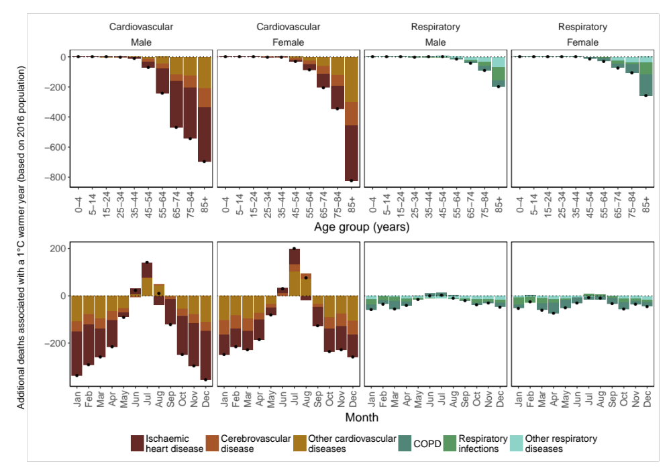
Figure 49. Additional annual cardiorespiratory disease deaths for the 2016 US population in year in which each month was +1°C compared with 1980-2009 norm temperatures.
The top row shows breakdown by type of cardiorespiratory disease, sex and age group. The bottom row shows the break down by cardiorespiratory disease, sex and month. Black dots represent net changes in deaths for each set of bars.

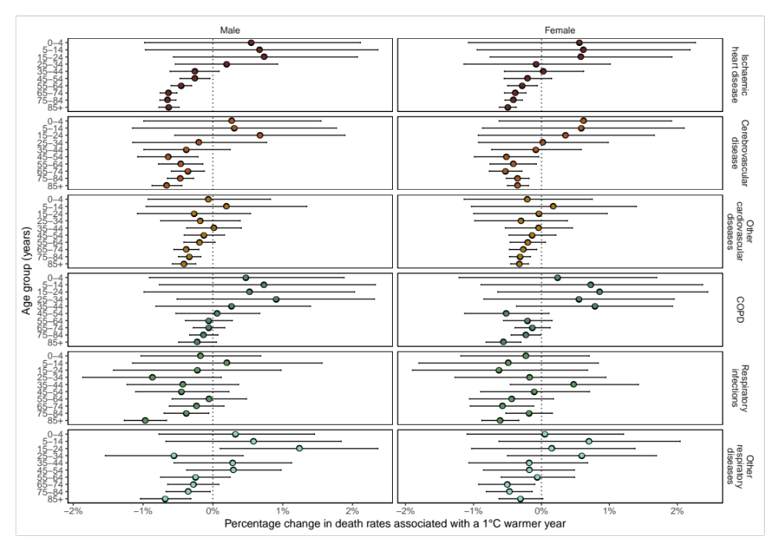
Figure 50. Percent change in death rates in year in which each month was +1°C compared with 1980-2009 norm temperatures by cardiorespiratory disease, sex and age group summarised across months.

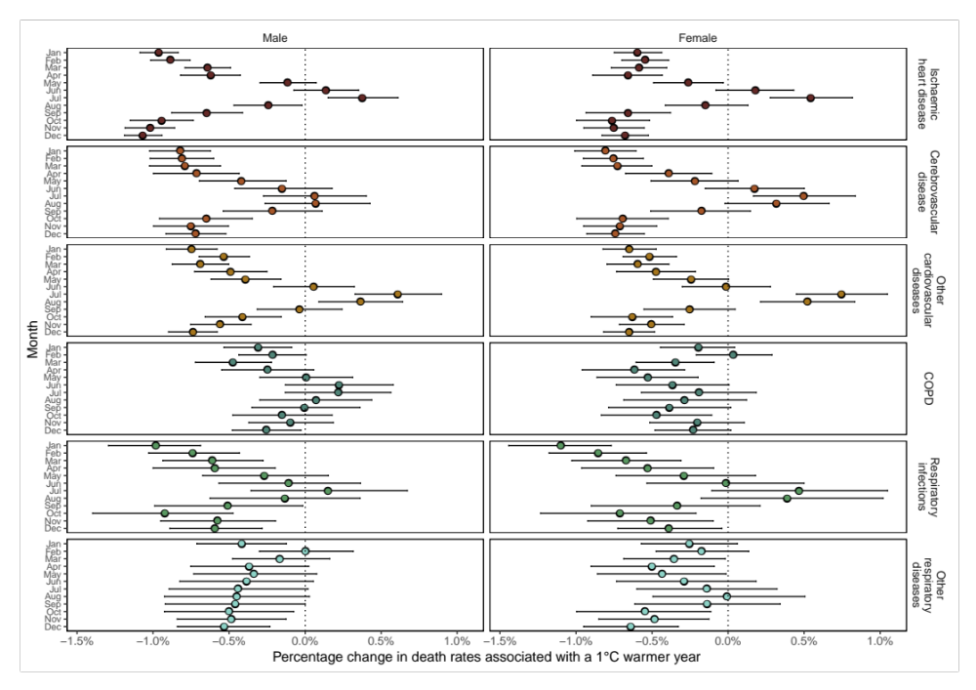
Figure 51. Percent change in death rates in year in which each month was +1°C compared with 1980-2009 norm temperatures by cardiorespiratory disease, sex and month summarised across age.


Figure 52. Excess relative risk in ischaemic heart disease death rates in year in which each month was +1°C compared with 1980-2009 norm temperatures by month, sex and age group.

Figure 53. Excess relative risk in cerebrovascular disease death rates in year in which each month was +1°C compared with 1980-2009 norm temperatures by month, sex and age group.

Figure 54. Excess relative risk in other cardiovascular disease death rates in year in which each month was +1°C compared with 1980-2009 norm temperatures by month, sex and age group.

Figure 55. Excess relative risk in COPD death rates in year in which each month was +1°C compared with 1980-2009 norm temperatures by month, sex and age group.

Figure 56. Excess relative risk in respiratory infection death rates in year in which each month was +1°C compared with 1980-2009 norm temperatures by month, sex and age group.

Figure 57. Excess relative risk in other respiratory disease death rates in year in which each month was +1°C compared with 1980-2009 norm temperatures by month, sex and age group.

Figure 58. Excess relative risk in cancer death rates in year in which each month was +1°C compared with 1980-2009 norm temperatures by month, sex and age group.
Percentage change in death rates in a year in which each month in each state were +1°C above its long-term norm varied by state and month in both males and females (Figure 59 and Figure 60). In January, an illustrative month for the impacts of anomalous temperature in winter months, there were decreases in percentage change in death rates across the entire contiguous United States (Figure 59 and Figure 60). These decreases ranged from -1.5% (-1.2%, -1.9%) (Louisiana) to -0.2% (-0.1%, -0.4%) (New Mexico) in males (Figure 59), and -1.3% (-1.0%, -1.7%) (Washington) to -0.1% (-0.5%, 0.3%) (Arizona) in females (Figure 60). In July, an illustrative month for the impact of anomalous temperature in summer months, there were increases in 47 out of the 48 contiguous states with District of Columbia for males (Figure 59) and all states for females (Figure 60). The biggest increase in July for males was in New Mexico, at 1.1% (0.5%, 1.7%) (Figure 59) and in Utah, at 1.2% (0.6%, 1.7%) for females (Figure 60). The months other than January and July showed more variation between states, though broadly consistent with national monthly percentage change in deaths from the majority of cardiorespiratory disease deaths in Figure 51.

Figure 59. Percent change in death rates for males in year in which each month was +1°C compared with 1980-2009 norm temperatures for all cardiorespiratory diseases by state and month summarised across age groups.

Figure 60. Percent change in death rates for females in year in which each month was +1°C compared with 1980-2009 norm temperatures for all cardiorespiratory diseases by state and month summarised across age groups.

Discussion
[[[1-2 sentences summary? See injury chapter and follow]]] Most previous studies have examined how deaths from natural causes2,3,5–7,87,88,98,100–103,105,106,119–124 and cardiorespiratory disease deaths3,5–7,87,88,107,113,115,122–128 are associated with daily temperature. While not directly comparable, my results align well when comparing to a similar study which associated seasonal average temperatures to mortality. A study in the United States of the New England Medicare population (men and women 65 years and over) estimated that 1°C higher summer average temperatures would result in a 1.0% (0.6%, 1.5%) higher all cause death rate.¹⁰⁵ This compares with my findings in July of a 0.5-0.9% increase in females and 0.2-0.3% increase in males in age groups 65 and over for ischaemic heart disease deaths (Figure 52), and 0.7-0.9% in females and 0.2-0.6% in males for other cardiovascular disease deaths (Figure 54). The same New England study predicted a 0.6% (0.3%, 0.9%) decrease in mortality in winter months for a 1°C higher average temperature.¹⁰⁵ This compares with my findings in January of a 0.5-0.6% decrease in females and 0.8-1.0% decrease in males in age groups 65 and over for ischaemic heart disease deaths (Figure 52), and 0.4-0.7% in females and 1.0-1.1% in males for other cardiovascular disease deaths (Figure 54). My subnational results for cardiorespiratory deaths (Figure 59 and Figure 60) show that this result is broadly consistent across the contiguous United States.
There are plausible explanations for my results. Cardiovascular deaths are higher in the winter than the summer (Figure 47). This is partially explained by blood pressure being inversely associated with temperature.¹³⁰ Average temperatures in winter months therefore result in generally higher blood pressure, placing strain on the heart and damaging vessel walls.¹³⁰ The lower norm temperatures in winter months can also lead to increased blood clotting and thrombosis.^{98,130} This increases the risk of ischaemic heart disease and cerebrovascular disease.⁹⁸ Warm anomalies in winter months will therefore reduce risk of dying from these causes (Figure 49). That warmer temperatures in summer months increase risk of death in cardiovascular diseases is thought to be due to the reduction of plasma volume by release of platelets and red blood cells into the blood stream and the loss of water and salt through sweating.¹³² This puts strain on the circulatory system by increasing sticking of platelets to artery walls which leads to blockages and sudden decrease in blood pressure and can lead to death.¹³² Further increases away from long-term norms increase strain on the circulatory system and risk of death from cardiovascular diseases. This helps to explain why more deaths are expected from cardiovascular diseases in anomalously warm summer months (Figure 49).
Respiratory disease deaths are also relatively higher in winter than at other times in the year in the United States (Figure 47). Colder temperatures are associated with suppression of immune system, which facilitates respiratory infections taking hold in humans.⁹⁸ Warmer anomalies in winter months can therefore reduce risks of respiratory infections, which explains the reduction in risk for older groups (Figure 56). Cold air can also cause airways to go into spasm and trigger coughing, wheezing, shortness of breath and tightness in the chest.²⁶⁸ Mould spores are more common in colder air, which are known to cause respiratory issues.²⁶⁹ Warmer anomalies in winter would reduce the risk factors. In contrast, warmer anomalous temperatures in summer months are associated with airway inflammation, which can lead to death from respiratory complications,¹³¹ though no consistent association of warm anomalies with deaths in the summer months is observed (Figure 49).
That I found no association between cancer deaths and anomalous temperature across months, age groups and sexes, matches the lack of evidence associating temperature variation with cancer mortality. Though I found that cancer deaths rates were weakly seasonal for 55 years and over in males and 65 years and over for females (Figure 15 and Figure 16 in Chapter 4), this may be for reasons other than temperature variation. For example, slightly more elderly terminally ill sufferers may die during winter months due to co-morbidity caused by increased susceptibility to respiratory infections which results in lower survival rates.²⁷⁰
The major strength of this study is that, when combined with my work in Chapter 6, I have comprehensively modelled the association of temperature anomaly with a mutually exclusive and collectively exhaustive set of causes of death, by month, age group, and sex. I did this using the two large datasets I processed in Chapter 3 and the Bayesian spatio-temporal I developed in Chapter 5. The temperature anomaly metric I also describe in Chapter 3 factors in long-term local experience, and associated adaptation, when examining temperature-mortality association. This has enabled me to make an estimate of the change in deaths with a 1°C anomaly increase, which is well within current estimates of an up to 6.6°C increase by the end of the 21st century in the United States.⁴⁴ My study design has also enabled me to show that the reduction in deaths would be greatest in older groups in the winter months, and is almost evenly shared between males and females (Figure 49). A limitation of my study is that I cannot rule out confounding of results due to other factors that may correlated with temperature anomalies. It is has been suggested that pollution should not be included in mortality and temperature studies due to the complex interaction and causality between them.¹⁵⁸ I also have not investigated the potential for the reduction in older deaths to be due to mortality displacement. Further work may investigate the association of temperature with deaths from causes other than cancers, cardiorespiratory diseases and injuries.
My work adds to the body of evidence that suggests that a warming world will reduce winter deaths.^{78–80,105} While increases in average temperatures will increase deaths in the summer, this will be outweighed by the reductions in winter. My work goes further than previous work by breaking down changes in deaths by cause of death, month, age group and sex (Figure 49). The predicted reduction of 0.4% of all cardiorespiratory deaths is slight and concentrated in older age groups. This demonstrates that the burden from cardiorespiratory deaths will remain large and a significant public health concern under climate change. Single-day or multi-day heat events will also clearly remain a threat to human lives.^{100–103}

Summary
In this chapter, I estimated how anomalous temperatures affect natural deaths in the United States by using the mortality and weather datasets would result in a net decrease in cardiorespiratory deaths. The majority of this reduction would be concentrated in older age groups shared evenly between males and females. Reductions would occur across the year apart from the summer months, when deaths would increase. I found no association between anomalous temperature and cancer deaths. I also examined how percentage change in cardiorespiratory deaths would vary from state to state. I found similar percentage changes in cardiorespiratory deaths across the United States.

Discussion

Comparison with published literature

Seasonal dynamics

Temperature and mortality
- Which gaps did previous literature have that I have now filled?
  - Using an entire large country’s dataset like the United States
  - Dynamic seasonality examination
  - Comprehensive analysis seasonality and temperature-mortality relationship for of all causes of death by age group, sex.
  - Using Bayesian spatio-temporal model for temperature framework allowing borrowing of strength etc.
- What agrees with what I have done and what doesn’t?
  - Seasonality
    - I think all good here
  - Anomalous temperature
    - Injuries etc
    - Cardiorespiratory with
- If it doesn’t agree, can I explain it?
  - Staddon stuff which I can explain with the fact that they have used excess winter deaths

Strengths and limitations
- What are the important contributions to science?
  - Improved way of analysing seasonality
  - Bayesian spatio-temporal model by month
  - First study to comprehensively examine the entire United States using all data
  - Processed mortality and temperature datasets
  - Could look at how the

Public health and policy implications
- What are the important implications to public health?
  - Seasonality
    - Much of seasonality remains since the 1980s
    - Vaccine implications?
  - Anomalous temperature
    - As temperature increases there is increased risk of injuries
    - As temperature increases, reduction in

Further work
- Further testing of model on other countries’ datasets
- As computing power improves, perhaps could create a single all-age model

Conclusions

Works cited
1 CDC. Estimates of influenza vaccination coverage among adults—United States, 2017–18 flu season. FluVaxView. 2018.
2 Gasparrini A, Guo Y, Hashizume M, et al. Mortality risk attributable to high and low ambient temperature: A multicountry observational study. Lancet 2015; 386: 369–75.
3 Basu R. High ambient temperature and mortality: A review of epidemiologic studies from 2001 to 2008. Environ Heal A Glob Access Sci Source 2009; 8: 40.
4 Ye X, Wolff R, Yu W, Vaneckova P, Pan X, Tong S. Ambient temperature and morbidity: a review of epidemiological evidence. Environ Health Perspect 2012; 120: 19–28.
5 Basu R, Samet JM. Relation between elevated ambient temperature and mortality: A review of the epidemiologic evidence. Epidemiol. Rev. 2002; 24: 190–202.
6 Kovats RS, Hajat S. Heat stress and public health: A critical review. Annu Rev Public Health 2008. DOI:10.1146/annurev.publhealth.29.020907.090843.
7 Song X, Wang S, Hu Y, et al. Impact of ambient temperature on morbidity and mortality: An overview of reviews. Sci Total Environ 2017; 586: 241–54.
8 WHO. COP24 special report: health and climate change. 2018.
9 UNFCCC. Paris Agreement. 2015.
10 Watts N, Amann M, Arnell N, et al. The 2018 report of the Lancet Countdown on health and climate change: shaping health of nations for centuries to come. Lancet 2018; 6736: 1–4.
11 WHO. World Health Statistics 2016 Monitoring Health for the SDGs. 2016.
12 Great Britain. Weekly return of births and deaths in London and in other great towns. Gen Regist Off 1876.
13 National Research Council (US) Committee on National Statistics. Vital Statistics: Summary of a Workshop. 2009 DOI:10.17226/12714.
14 WHO. WHO Methods and Data Sources for Country-Level Cause of Death 2000-2016. 2018; : 1–51.
15 Omran AR. A century of epidemiologic transition in the United States. Prev Med (Baltim) 1977. DOI:10.1016/0091-7435(77)90003-2.
16 Ma J, Ward EM, Siegel RL, Jemal A. Temporal trends in mortality in the United States, 1969-2013. JAMA - J Am Med Assoc 2015. DOI:10.1001/jama.2015.12319.
17 Murphy SL, Xu J, Kochanek KD, Arias E. Mortality in the United States, 2017. 2018.
18 WHO. WHO methods and data sources for life tables 1990-2016. 2018. http://www.who.int/healthinfo/statistics/LT_method.pdf.
19 Oeppen J, Vaupel JW. Broken Limits to Life Expectancy. Science (80- ) 2002. DOI:10.4054/DemRes.2011.24.11.
20 Ezzati M, Friedman AB, Kulkarni SC, Murray CJL. The reversal of fortunes: Trends in county mortality and cross-county mortality disparities in the United States. PLoS Med 2008. DOI:10.1371/journal.pmed.0050066.
21 Chetty R, Stepner M, Abraham S, et al. The association between income and life expectancy in the United States, 2001-2014. JAMA - J Am Med Assoc 2016. DOI:10.1001/jama.2016.4226.
22 Murray CJL, Kulkarni SC, Michaud C, et al. Eight Americas: Investigating mortality disparities across races, counties, and race-counties in the United States. PLoS Med 2006. DOI:10.1371/journal.pmed.0030260.
23 Pope CA, Ezzati M, Dockery DW. Fine-particulate air pollution and life expectancy in the United States. N Engl J Med 2009. DOI:10.1056/nejmsa0805646.
24 National Center for Health Statistics. Health, United States, 2017: With Special Feature on Mortality. 2017.
25 Riley JC. Rising life expectancy: A global history. 2015 DOI:10.1017/CBO9781316036495.
26 Kontis V, Bennett JE, Mathers CD, Li G, Foreman K, Ezzati M. Future life expectancy in 35 industrialised countries: projections with a Bayesian model ensemble. Lancet 2017. DOI:10.1016/S0140-6736(16)32381-9.
27 Foreman KJ, Marquez N, Dolgert A, et al. Forecasting life expectancy, years of life lost, and all-cause and cause-specific mortality for 250 causes of death: reference and alternative scenarios for 2016–40 for 195 countries and territories. Lancet 2018. DOI:10.1016/S0140-6736(18)31694-5.
28 Olshansky SJ, Passaro DJ, Hershow RC, et al. A Potential Decline in Life Expectancy in the United States in the 21st Century. N Engl J Med 2005; 60: 450–2.
29 Costello A, Abbas M, Allen A, et al. Managing the health effects of climate change. Lancet 2009; 373: 1693–733.
30 Wallace JM, Hobbs P V. Atmospheric science: An introductory survey: Second edition. 2006 DOI:10.1016/C2009-0-00034-8.
31 India Meteorological Department. History of meteorological services in India. Gov. India. 2018. http://www.imd.gov.in/pages/about_history.php (accessed April 2, 2019).
32 Middleton WEK. A history of the thermometer. Johns Hopkins, Baltimore, 1966.
33 Middleton WEK. A brief history of the barometer. J R Astron Soc Canada 1944; 28.
34 Manley G. Central England temperatures: Monthly means 1659 to 1973. Q J R Meteorol Soc 1974. DOI:10.1002/qj.49710042511.
35 Vose RS, Applequist S, Squires M, et al. Improved historical temperature and precipitation time series for U.S. climate divisions. J Appl Meteorol Climatol 2014. DOI:10.1175/JAMC-D-13-0248.1.
36 NOAA. NOAA weather stations. arcgis.com. 2014. https://www.arcgis.com/home/webmap/viewer.html?webmap=fa40207019de41bc9a37ea1f5235ae0c (accessed Jan 8, 2019).
37 Karl TR, Koss WJ. Regional and national monthly, seasonal, and annual temperature weighted by area, 1895-1983. Natl Clim Data Cent 1984; : 38.
38 Parks RM, Bennett JE, Foreman KJ, Toumi R, Ezzati M. National and regional seasonal dynamics of all-cause and cause-specific mortality in the USA from 1980 to 2016. Elife 2018; 7. DOI:10.7554/eLife.35500.
39 Fall S, Watts A, Nielsen-Gammon J, et al. Analysis of the impacts of station exposure on the US historical climatology Network temperatures and temperature trends. J Geophys Res Atmos 2011. DOI:10.1029/2010JD015146.
40 Karl TR, Melillo JT, Peterson TC. Global climate change impacts in the United States. Cambridge University Press, 2009.
41 Menne MJ, Williams CN, Palecki MA. On the reliability of the U.S. surface temperature record. J Geophys Res Atmos 2010. DOI:10.1029/2009JD013094.
42 Menne MJ, Williams CN, Vose RS. The U.S. historical climatology network monthly temperature data, version 2. Bull Am Meteorol Soc 2009. DOI:10.1175/2008BAMS2613.1.
43 Menne MJ, Williams CN. Homogenization of temperature series via pairwise comparisons. J Clim 2009. DOI:10.1175/2008JCLI2263.1.
44 Sun L, Kunkel KE, Stevens LE, Buddenberg A, Dobson JG, Easterling DR. Regional surface climate conditions in CMIP3 and CMIP5 for the United States: Differences, similarities, and implications for the US national climate assessment. NOAA Tech Rep NESDIS 144 2015; : 111-p.
45 Xu Z, FitzGerald G, Guo Y, Jalaludin B, Tong S. Impact of heatwave on mortality under different heatwave definitions: A systematic review and meta-analysis. Environ. Int. 2016. DOI:10.1016/j.envint.2016.02.007.
46 Habeeb D, Vargo J, Stone B. Rising heat wave trends in large US cities. Nat Hazards 2015. DOI:10.1007/s11069-014-1563-z.
47 US global change research program. Heat waves. 2018. https://www.globalchange.gov/browse/indicators/us-heat-waves (accessed May 20, 2019).
48 Jones B, O’Neill BC, McDaniel L, McGinnis S, Mearns LO, Tebaldi C. Future population exposure to US heat extremes. Nat Clim Chang 2015; 5: 652–5.
49 Mora C, Dousset B, Caldwell IR, et al. Global risk of deadly heat. Nat Clim Chang 2017; 7: 501–6.
50 Rogot E, Fabsitz R, Feinleib M. Daily variation In USA mortality. Am J Epidemiol 1976. DOI:10.1093/oxfordjournals.aje.a112218.
51 Miller G. ‘Airs, waters, and places’ in history. J Hist Med Allied Sci 1962. DOI:10.1093/jhmas/XVII.1.129.
52 Shaw BD. Seasons of death: aspects of mortality in Imperial Rome. J Rom Stud 2006. DOI:10.2307/300425.
53 Healy JD. Excess winter mortality in Europe: A cross country analysis identifying key risk factors. J Epidemiol Community Health 2003; 57: 784–9.
54 Reichert TA, Simonsen L, Sharma A, Pardo SA, Fedson DS, Miller MA. Influenza and the winter increase in mortality in the United States, 1959-1999. Am J Epidemiol 2004. DOI:10.1093/aje/kwh227.
55 Brown G, Fearn V, Wells C. Exploratory analysis of seasonal mortality in England and Wales, 1998 to 2007. Heal Stat Q 2010. DOI:10.1057/hsq.2010.21.
56 Mercer JB. Cold - An underrated risk factor for health. Environ. Res. 2003. DOI:10.1016/S0013-9351(02)00009-9.
57 ONS. Excess winter mortality in England and Wales. Stat. Bull. 2019. https://www.ons.gov.uk/peoplepopulationandcommunity/birthsdeathsandmarriages/deaths/bulletins/excesswintermortalityinenglandandwales/previousReleases.
58 Rau R. Seasonality in human mortality. A demographic approach. Wirtschafts- und Sozialwissenschaftlichen Fak 2004; PhD: 361.
59 Rosenwaike I. Seasonal variation of deaths in the United States, 1951–1960. J Am Stat Assoc 1966; 61: 706–19.
60 Feinstein CA. Seasonality of deaths in the US by age and cause. Demogr Res 2002; 6: 469–86.
61 Kalkstein AJ. Regional similarities in seasonal mortality across the United States: An examination of 28 metropolitan statistical areas. PLoS One 2013; 8. DOI:10.1371/journal.pone.0063971.
62 Trudeau R. Monthly and daily patterns of death. Stat Canada 1997; 9.
63 Gemmell I, McLoone P, Boddy FA, Dickinson GJ, Watt GCM. Seasonal variation in mortality in Scotland. Int J Epidemiol 2000. DOI:10.1093/ije/29.2.274.
64 Marti-Soler H, Gonseth S, Gubelmann C, et al. Seasonal variation of overall and cardiovascular mortality: A study in 19 countries from different geographic locations. PLoS One 2014. DOI:10.1371/journal.pone.0113500.
65 Laake K, Sverre JM. Winter excess mortality: A comparison between Norway and England plus Wales. Age Ageing 1996. DOI:10.1093/ageing/25.5.343.
66 Mackenbach JP, Kunst AE, Looman CWN. Seasonal variation in mortality in the Netherlands. J Epidemiol Community Health 1992; 46: 261–5.
67 Green MS, Harari G, Kristal-Boneh E. Excess winter mortality from ischaemic heart disease and stroke during colder and warmer years in Israel: An evaluation and review of the role of environmental temperature. Eur J Public Health 2007. DOI:10.1093/eurpub/4.1.3.
68 Nakaji S, Parodi S, Fontana V, et al. Seasonal changes in mortality rates from main causes of death in Japan. Eur J Epidemiol 2004. DOI:10.1007/s10654-004-4695-8.
69 Rau R, Bohk-Ewald C, Muszyńska MM, Vaupel JW. Visualizing mortality dynamics in the Lexis diagram. 2018 DOI:10.1007/978-3-319-64820-0.
70 Dushoff J, Plotkin JB, Viboud C, Earn DJD, Simonsen L. Mortality due to influenza in the United States - An annualized regression approach using multiple-cause mortality data. Am J Epidemiol 2006. DOI:10.1093/aje/kwj024.
71 WHO. Influenza (seasonal) fact sheet. 2018. https://www.who.int/news-room/fact-sheets/detail/influenza-(seasonal) (accessed May 20, 2019).
72 Nguyen JL, Yang W, Ito K, Matte TD, Shaman J, Kinney PL. Seasonal influenza infections and cardiovascular disease mortality. JAMA Cardiol 2016. DOI:10.1001/jamacardio.2016.0433.
73 Simonsen L, Reichert TA, Viboud C, Blackwelder WC, Taylor RJ, Miller MA. Impact of influenza vaccination on seasonal mortality in the US elderly population. Arch Intern Med 2005; 165: 265–72.
74 Simonsen L, Taylor RJ, Viboud C, Miller MA, Jackson LA. Mortality benefits of influenza vaccination in elderly people: an ongoing controversy. Lancet Infect. Dis. 2007. DOI:10.1016/S1473-3099(07)70236-0.
75 Rolfes MA, Flannery B, Chung J, et al. Effects of influenza vaccination in the United States during the 2017–2018 influenza Season. Clin Infect Dis 2019. DOI:10.1093/cid/ciz075.
76 Wu NC, Zost SJ, Thompson AJ, et al. A structural explanation for the low effectiveness of the seasonal influenza H3N2 vaccine. PLoS Pathog 2017. DOI:10.1371/journal.ppat.1006682.
77 Paules CI, Sullivan SG, Subbarao K, Fauci AS. Chasing seasonal influenza — The need for a universal influenza vaccine. N Engl J Med 2017. DOI:10.1056/nejmp1714916.
78 Ballester J, Rodó X, Robine J, Herrmann FR. European seasonal mortality and influenza incidence due to winter temperature variability. Nat Clim Chang 2016; 6: 6–10.
79 Kinney PL, Schwartz J, Pascal M, et al. Winter season mortality: Will climate warming bring benefits? Environ Res Lett 2015; 10. DOI:10.1088/1748-9326/10/6/064016.
80 Hajat S, Gasparrini A. The excess winter deaths measure: Why its use is misleading for public health understanding of cold-related health impacts. Epidemiology 2016. DOI:10.1097/EDE.0000000000000479.
81 Hajat S, Kovats S. A note of caution about the excess winter deaths measure. Nat Clim Chang 2014.
82 Taylor NAS. Human heat adaptation. Compr Physiol 2014. DOI:10.1002/cphy.c130022.
83 IPCC. Climate Change 2014 – Impacts, adaptation and vulnerability: Part B: Regional aspects: Working group II contribution to the IPCC Fifth Assessment Report. Cambridge University Press, 2014 DOI:doi:10.1017/CBO9781107415386.
84 Pfister C, Brázdil R, Glaser R, et al. Documentary evidence on climate in sixteenth-century Europe. Clim Change 1999. DOI:10.1023/A:1005540707792.
85 Luterbacher J, Dietrich D, Xoplaki E, Grosjean M, Wanner H. European seasonal and annual temperature variability, trends, and extremes since 1500. Science (80- ) 2004. DOI:10.1126/science.1093877.
86 Semenza JC, Rubin CH, Falter KH, et al. Heat-related deaths during the July 1995 heat wave in Chicago. N Engl J Med 1996. DOI:10.1056/NEJM199607113350203.
87 Kaiser R, Le Tertre A, Schwartz J, Gotway CA, Daley WR, Rubin CH. The effect of the 1995 heat wave in Chicago on all-cause and cause-specific mortality. Am J Public Health 2007. DOI:10.2105/AJPH.2006.100081.
88 Garcia-Herrera R, Díaz J, Trigo RM, Luterbacher J, Fischer EM. A review of the European summer heat wave of 2003. Crit. Rev. Environ. Sci. Technol. 2010. DOI:10.1080/10643380802238137.
89 Parsons K. Human thermal environments: The effects of hot, moderate, and cold environments on human health, comfort, and performance. CRC Press, 2014 DOI:10.1016/0003-6870(94)90062-0.
90 Bouchama A, Knochel JP. Heat stroke. N Engl J Med 2002; 346. DOI:10.1002/cphy.c140017.
91 Kilbourne EM. Heat waves and hot environments. Oxford University Press, 1997.
92 UNISDR. Sendai Framework for Disaster Risk Reduction 2015 - 2030. Third World Conf Disaster Risk Reduction, Sendai, Japan, 14-18 March 2015 2015; : 1–25.
93 Department of Homeland Security. Extreme heat. ready.gov. 2019. https://www.ready.gov/heat (accessed May 8, 2019).
94 Borden KA, Cutter SL. Spatial patterns of natural hazards mortality in the United States. Int J Health Geogr 2008. DOI:10.1186/1476-072X-7-64.
95 NOAA. Weather fatalities 2018. 2018. https://www.nws.noaa.gov/om/hazstats.shtml (accessed May 20, 2019).
96 Shapiro E. 5 natural disasters that devastated the US in 2018. abc News. 2018. https://abcnews.go.com/US/natural-disasters-devastated-us-2018/story?id=59367683 (accessed May 20, 2019).
97 EPA. Climate change indicators: heat-related deaths. 2017. https://www.epa.gov/climate-indicators/climate-change-indicators-heat-related-deaths (accessed May 20, 2019).
98 The Eurowinter Group. Cold exposure and winter mortality from ischaemic heart disease, cerebrovascular disease, respiratory disease, and all causes in warm and cold regions of Europe. Lancet 1997; 349: 1341–6.
99 IPCC. Climate Change 2014 Synthesis Report. 2014.
100 Anderson BG, Bell ML. Weather-related mortality: how heat, cold, and heat waves affect mortality in the United States. Epidemiology 2009; 20: 205.
101 Gasparrini A, Armstrong B. The impact of heat waves on mortality. Epidemiol 2011. DOI:10.1097/EDE.0b013e3181fdcd99.
102 Hajat S, Armstrong B, Baccini M, et al. Impact of high temperatures on mortality: Is there an added heat wave effect? Epidemiology 2006. DOI:10.1097/01.ede.0000239688.70829.63.
103 Guo Y, Gasparrini A, Armstrong BG, et al. Heat wave and mortality: A multicountry, multicommunity study. Env Heal Perspect 2017; : 1–11.
104 Burke M, González F, Baylis P, et al. Higher temperatures increase suicide rates in the United States and Mexico. Nat Clim Chang 2018. DOI:10.1038/s41558-018-0222-x.
105 Shi L, Kloog I, Zanobetti A, Liu P, Schwartz JD. Impacts of temperature and its variability on mortality in New England. Nat Clim Chang 2015; 5: 988–91.
106 Gasparrini A, Guo Y, Hashizume M, et al. Changes in susceptibility to heat during the summer: a multicountry analysis. Am J Epidemiol 2016; 183: 1027–36.
107 Basu R, Ostro BD. A multicounty analysis identifying the populations vulnerable to mortality associated with high ambient temperature in California. Am J Epidemiol 2008. DOI:10.1093/aje/kwn170.
108 Brooke Anderson G, Bell ML. Heat waves in the United States: Mortality risk during heat waves and effect modification by heat wave characteristics in 43 U.S. communities. Environ Health Perspect 2011. DOI:10.1289/ehp.1002313.
109 Schwartz J. Who is sensitive to extremes of temperature? A case-only analysis. Epidemiology 2005. DOI:10.1097/01.ede.0000147114.25957.71.
110 Madrigano J, Jack D, Anderson GB, Bell ML, Kinney PL. Temperature, ozone, and mortality in urban and non-urban counties in the northeastern United States. Environ Heal A Glob Access Sci Source 2015. DOI:10.1186/1476-069X-14-3.
111 Ferreira Braga AL, Zanobetti A, Schwartz J. The time course of weather-related deaths. Epidemiology 2001; 12: 662–7.
112 O’Neill MS, Zanobetti A, Schwartz J. Modifiers of the temperature and mortality association in seven US cities. Am J Epidemiol 2003. DOI:10.1093/aje/kwg096.
113 Braga ALF, Zanobetti A, Schwartz J. The effect of weather on respiratory and cardiovascular deaths in 12 U.S. cities. Environ Health Perspect 2002; 110: 859–63.
114 O’Neill MS, Zanobetti A, Schwartz J. Disparities by race in heat-related mortality in four US cities: The role of air conditioning prevalence. J Urban Heal 2005. DOI:10.1093/jurban/jti043.
115 Basu R, Dominici F, Samet JM. Temperature and mortality among the elderly in the United States: a comparison of epidemiologic methods. Epidemiology 2005; 16: 58–66.
116 Medina-Ramón M, Zanobetti A, Cavanagh DP, Schwartz J. Extreme temperatures and mortality: Assessing effect modification by personal characteristics and specific cause of death in a multi-city case-only analysis. Environ Health Perspect 2006. DOI:10.1289/ehp.9074.
117 Bobb JF, Dominici F, Peng RD. A Bayesian model averaging approach for estimating the relative risk of mortality associated with heat waves in 105 U.S. cities. Biometrics 2011. DOI:10.1111/j.1541-0420.2011.01583.x.
118 Zanobetti A, O’Neill MS, Gronlund CJ, Schwartz JD. Summer temperature variability and long-term survival among elderly people with chronic disease. Proc Natl Acad Sci 2012. DOI:10.1073/pnas.1113070109.
119 Carmona R, Díaz J, Mirón IJ, Ortiz C, Luna MY, Linares C. Mortality attributable to extreme temperatures in Spain: A comparative analysis by city. Environ Int 2016. DOI:10.1016/j.envint.2016.02.018.
120 Le Tertre A, Lefranc AA, Eilstein D, et al. Impact of the 2003 heatwave on all-cause mortality in 9 French cities. Epidemiology 2006; 17: 75–9.
121 Sheridan SC, Lee CC, Allen MJ. The mortality response to absolute and relative temperature extremes. Environ Res public Heal 2019.
122 Baccini M, Biggeri A, Accetta G, et al. Heat effects on mortality in 15 European cities. Epidemiology 2008. DOI:10.1097/EDE.0b013e318176bfcd.
123 Stafoggia M, Forastiere F, Agostini D, et al. Vulnerability to heat-related mortality: A multicity, population-based, case-crossover analysis. Epidemiology 2006. DOI:10.1097/01.ede.0000208477.36665.34.
124 Gasparrini A, Armstrong B, Kovats S, Wilkinson P. The effect of high temperatures on cause-specific mortality in England and Wales. Occup Environ Med 2012. DOI:10.1136/oem.2010.059782.
125 Bennett JE, Blangiardo M, Fecht D, Elliott P, Ezzati M. Vulnerability to the mortality effects of warm temperature in the districts of England and Wales. Nat Clim Chang 2014; 4: 269–73.
126 Ishigami A, Hajat S, Kovats RS, et al. An ecological time-series study of heat-related mortality in three European cities. Environ Heal A Glob Access Sci Source 2008. DOI:10.1186/1476-069X-7-5.
127 Kolb S, Radon K, Valois MF, Héguy L, Goldberg MS. The short-term influence of weather on daily mortality in congestive heart failure. Arch Environ Occup Heal 2007. DOI:10.3200/AEOH.62.4.169-176.
128 Kunst AE, Looman CWN, Mackenbach JP. Outdoor air temperature and mortality in the Netherlands: A time-series analysis. Am J Epidemiol 1993. DOI:10.1093/oxfordjournals.aje.a116680.
129 Dilaveris P, Synetos A, Giannopoulos G, Gialafos E, Pantazis A, Stefanadis C. Climate impacts on myocardial infarction deaths in the Athens Territory: The CLIMATE study. Heart 2006. DOI:10.1136/hrt.2006.091884.
130 Wilmshurst P. Temperature and cardiovascular mortality. BMJ 1994. DOI:10.1136/bmj.309.6961.1029.
131 Michelozzi P, Accetta G, De Sario M, et al. High temperature and hospitalizations for cardiovascular and respiratory causes in 12 european cities. Am J Respir Crit Care Med 2009. DOI:10.1164/rccm.200802-217OC.
132 Keatinge WR, Coleshaw SRK, Easton JC, Cotter F, Mattock MB, Chelliah R. Increased platelet and red cell counts, blood viscosity, and plasma cholesterol levels during heat stress, and mortality from coronary and cerebral thrombosis. Am J Med 1986. DOI:10.1016/0002-9343(86)90348-7.
133 Orru H, Åström DO. Increases in external cause mortality due to high and low temperatures: evidence from northeastern Europe. Int J Biometeorol 2017. DOI:10.1007/s00484-016-1270-4.
134 Rey G, Jougla E, Fouillet A, et al. The impact of major heat waves on all-cause and cause-specific mortality in France from 1971 to 2003. Int Arch Occup Environ Health 2007. DOI:10.1007/s00420-007-0173-4.
135 Xiang J, Bi P, Pisaniello D, Hansen A. Health impacts of workplace heat exposure: An epidemiological review. Ind Health 2014; 52: 91–101.
136 Xue T, Zhu T, Zheng Y, Zhang Q. Declines in mental health associated with air pollution and temperature variability in China. Nat Commun 2019; 10: 2165.
137 Newell GR, Waggoner DE. Cancer mortality and environmental temperature in the United States. Lancet 1970. DOI:10.1016/S0140-6736(70)90988-8.
138 Choi KS, Inoue S, Shinozaki R. Air pollution, temperature, and regional differences in lung cancer mortality in japan. Arch Environ Health 1997. DOI:10.1080/00039899709602881.
139 Yan YY. The influence of weather on human mortality in Hong Kong. Soc Sci Med 2000. DOI:10.1016/S0277-9536(99)00301-9.
140 Ito K, Thurston GD. Daily PM10/mortality associations: an investigations of at-risk subpopulations. J Expo Anal Environ Epidemiol 1996.
141 Glaser J, Lemery J, Rajagopalan B, et al. Climate change and the emergent epidemic of CKD from heat stress in rural communities: The case for heat stress nephropathy. Clin J Am Soc Nephrol 2016. DOI:10.2215/CJN.13841215.
142 Pearce N, Caplin B. Let’s take the heat out of the CKDu debate: more evidence is needed. Occup Environ Med 2019. DOI:10.1136/oemed-2018-105427.
143 Burse RL. Sex differences in human thermoregulatory response to heat and cold stress. Hum Factors J Hum Factors Ergon Soc 1979. DOI:10.1177/001872087912210606.
144 Hajat S, Kovats RS, Lachowycz K. Heat-related and cold-related deaths in England and Wales: Who is at risk? Occup Environ Med 2007. DOI:10.1136/oem.2006.029017.
145 Díaz J, Linares C, Tobías A. Impact of extreme temperatures on daily mortality in Madrid (Spain) among the 45-64 age-group. Int J Biometeorol 2006. DOI:10.1007/s00484-006-0033-z.
146 Bell ML, O’Neill MS, Ranjit N, Borja-Aburto VH, Cifuentes LA, Gouveia NC. Vulnerability to heat-related mortality in Latin America: A case-crossover study in São Paulo, Brazil, Santiago, Chile and Mexico City, Mexico. Int J Epidemiol 2008. DOI:10.1093/ije/dyn094.
147 Rainham DGC, Smoyer-Tomic KE. The role of air pollution in the relationship between a heat stress index and human mortality in Toronto. Environ Res 2003. DOI:10.1016/S0013-9351(03)00060-4.
148 Vaneckova P, Beggs PJ, de Dear RJ, McCracken KWJ. Effect of temperature on mortality during the six warmer months in Sydney, Australia, between 1993 and 2004. Environ Res 2008. DOI:10.1016/j.envres.2008.07.015.
149 El-Zein A, Tewtel-Salem M, Nehme G. A time-series analysis of mortality and air temperature in Greater Beirut. Sci Total Environ 2004. DOI:10.1016/j.scitotenv.2004.02.027.
150 Hajat S, Vardoulakis S, Heaviside C, Eggen B. Climate change effects on human health: Projections of temperature-related mortality for the UK during the 2020s, 2050s and 2080s. J Epidemiol Community Health 2014. DOI:10.1136/jech-2013-202449.
151 Li T, Horton RM, Bader DA, et al. Aging will amplify the heat-related mortality risk under a changing climate: Projection for the elderly in Beijing, China. Sci Rep 2016. DOI:10.1038/srep28161.
152 O’Neill MS, Hajat S, Zanobetti A, Ramirez-Aguilar M, Schwartz J. Impact of control for air pollution and respiratory epidemics on the estimated associations of temperature and daily mortality. Int J Biometeorol 2005. DOI:10.1007/s00484-005-0269-z.
153 Gouveia N, Hajat S, Armstrong B. Socioeconomic differentials in the temperature-mortality relationship in São Paulo, Brazil. Int J Epidemiol 2003. DOI:10.1093/ije/dyg077.
154 Xu Y, Dadvand P, Barrera-Gómez J, et al. Differences on the effect of heat waves on mortality by sociodemographic and urban landscape characteristics. J Epidemiol Community Health 2013. DOI:10.1136/jech-2012-201899.
155 Rey G, Fouillet A, Bessemoulin P, et al. Heat exposure and socio-economic vulnerability as synergistic factors in heat-wave-related mortality. Eur J Epidemiol 2009. DOI:10.1007/s10654-009-9374-3.
156 Barnett AG, Tong S, Clements ACA. What measure of temperature is the best predictor of mortality? Environ Res 2010. DOI:10.1016/j.envres.2010.05.006.
157 Fanger P. Thermal comfort: Analysis and applications in environmental engineering. McGraw-Hill, New York, 1972 DOI:10.1016/s0003-6870(72)80074-7.
158 Buckley JP, Samet JM, Richardson DB. Does air pollution confound studies of temperature? Epidemiology. 2014. DOI:10.1097/EDE.0000000000000051.
159 Saha M V., Davis RE, Hondula DM. Mortality displacement as a function of heat event strength in 7 US cities. Am J Epidemiol 2014. DOI:10.1093/aje/kwt264.
160 Armstrong B, Gasparrini A, Hajat S. Estimating mortality displacement during and after heat waves. Am J Epidemiol 2014. DOI:10.1093/aje/kwu083.
161 Armstrong B. Models for the relationship between ambient temperature and daily mortality. Epidemiology 2006. DOI:10.1097/01.ede.0000239732.50999.8f.
162 Dominici F. Time-series analysis of air pollution and mortality: a statistical review. Res Rep Health Eff Inst 2004.
163 Armstrong BG, Gasparrini A, Tobias A. Conditional Poisson models: A flexible alternative to conditional logistic case cross-over analysis. BMC Med Res Methodol 2014. DOI:10.1186/1471-2288-14-122.
164 Maclure M. The case-crossover design: A method for studying transient effects on the risk of acute events. Am J Epidemiol 1991. DOI:10.1093/aje/kwx105.
165 Gasparrini A. Distributed lag linear and non-linear models in R: The package dlnm. J Stat Softw 2011.
166 Larsen U. The effects of monthly temperature fluctuations on mortality in the United States from 1921 to 1985. Int J Biometeorol 1990. DOI:10.1007/bf01048710.
167 Elliott P, Wakefield J, Best N, Briggs D. Spatial epidemiology: Methods and applications. Oxford University Press, 2001 DOI:10.1093/ije/30.5.1204.
168 Aykroyd RG. Bayesian modeling of temperature-related mortality with latent functional relationships. Commun. Stat. - Theory Methods. 2018. DOI:10.1080/03610926.2017.1421223.
169 Baccini M, Kosatsky T, Analitis A, et al. Impact of heat on mortality in 15 European cities: attributable deaths under different weather scenarios. J Epidemiol Community Heal 2011; 65: 64–70.
170 Yu W, Mengersen K, Wang X, et al. Daily average temperature and mortality among the elderly: A meta-analysis and systematic review of epidemiological evidence. Int. J. Biometeorol. 2012. DOI:10.1007/s00484-011-0497-3.
171 Thomas A, Best N, Way R, et al. WinBUGS User Manual. Components 2003. DOI:http://www.mrc-bsu.cam.ac.uk/wp-content/uploads/manual14.pdf.
172 Depaoli S, Clifton JP, Cobb PR. Just Another Gibbs Sampler (JAGS): Flexible Software for MCMC Implementation. J Educ Behav Stat 2016. DOI:10.3102/1076998616664876.
173 Stan Development Team. Stan: A C++ Library for Probability and Sampling. 2014.
174 Rue H, Martino S, Chopin N. Approximate Bayesian inference for latent Gaussian models by using integrated nested Laplace approximations. J R Stat Soc Ser B Stat Methodol 2009. DOI:10.1111/j.1467-9868.2008.00700.x.
175 Kristensen K, Nielsen A, Berg CW, Skaug H, Bell BM. TMB: Automatic Differentiation and Laplace Approximation. J Stat Softw 2016.
176 Mathers CD, Fat DM, Inoue M, Rao C, Lopez AD. Counting the dead and what they died from: An assessment of the global status of cause of death data. Bull World Health Organ 2005.
177 Boerma JT, Stansfield SK. Health statistics now: are we making the right investments? Lancet. 2007. DOI:10.1016/S0140-6736(07)60364-X.
178 Central statistics office. 2010 Census of population and housing. 2012.
179 Lind D. The citizenship question on the 2020 census, explained. Vox.com. 2018. https://www.vox.com/policy-and-politics/2018/3/28/17168048/census-citizenship-2020-immigrants-count-trump-lawsuit (accessed May 11, 2019).
180 United States Census Bureau. Methodology for the Intercensal Population and Housing Unit Estimates: 2000 to 2010. 2012 https://www2.census.gov/programs-surveys/popest/technical-documentation/methodology/intercensal/2000-2010-intercensal-estimates-methodology.pdf.
181 Ingram DD, Parker JD, Schenker N, et al. United States Census 2000 population with bridged race categories. Vital Health Stat 2 2003; : 1–55.
182 United States Census Bureau. County Intercensal Tables 1980-1990. 2016. https://www.census.gov/data/tables/time-series/demo/popest/1980s-county.html.
183 Fowler T, Southgate RJ, Waite T, et al. Excess winter deaths in Europe: A multi-country descriptive analysis. Eur J Public Health 2015; 25: 339–45.
184 Campbell A. Excess winter mortality in England and Wales: 2016 to 2017 (provisional) and 2015 to 2016 (final). Stat Bull Off Natl Stat 2017.
185 Messite J, Stellman SD. Accuracy of death certificate completion: The need for formalized physician training. J Am Med Assoc 1996. DOI:10.1001/jama.275.10.794.
186 Glasser JH. The quality and utility of death certificate data. Am J Public Health 1981. DOI:10.2105/AJPH.71.3.231.
187 Lu TH, Tsau SM, Wu TC. The Automated Classification of Medical Entities (ACME) system objectively assessed the appropriateness of underlying cause-of-death certification and assignment. J Clin Epidemiol 2005. DOI:10.1016/j.jclinepi.2005.03.017.
188 WHO. International Classification of Diseases 11th Revision. 2018. https://icd.who.int/en/.
189 WHO. ICD-10 International Statistical Classification of Diseases and Related Health Problems. 2011 DOI:10.1016/j.jclinepi.2009.09.002.
190 CDC. International Classification of Diseases, tenth revision, clinical modification (ICD-10-CM). 2018. https://www.cdc.gov/nchs/icd/icd10cm.htm (accessed April 12, 2019).
191 Anderson RN, Miniño AM, Hoyert DL, Rosenberg HM. Comparability of cause of death between ICD-9 and ICD-10: preliminary estimates. Natl Vital Stat Rep 2001.
192 Foreman KJ, Lozano R, Lopez AD, Murray CJL. Modeling causes of death: An integrated approach using CODEm. Popul Health Metr 2012. DOI:10.1186/1478-7954-10-1.
193 WHO. History of the development of the ICD. World Heal. Organ. 2019. https://www.who.int/classifications/icd/en/HistoryOfICD.pdf (accessed March 31, 2019).
194 D’Amico M, Agozzino E, Biagino A, Simonetti A, Marinelli P. Ill-defined and multiple causes on death certificates - A study of misclassification in mortality statistics. Eur J Epidemiol 1999. DOI:10.1023/A:1007570405888.
195 Lu TH, Anderson RN, Kawachi I. Trends in frequency of reporting improper diabetes-related cause-of-death statements on death certificates, 1985-2005: An algorithm to identify incorrect causal sequences. Am J Epidemiol 2010. DOI:10.1093/aje/kwq057.
196 McEwen LN, Karter AJ, Curb JD, Marrero DG, Crosson JC, Herman WH. Temporal trends in recording of diabetes on death certificates: Results from Translating Research into Action for Diabetes (TRIAD). Diabetes Care 2011. DOI:10.2337/dc10-2312.
197 Naghavi M, Abajobir AA, Abbafati C, et al. Global, regional, and national age-sex specifc mortality for 264 causes of death, 1980-2016: A systematic analysis for the Global Burden of Disease Study 2016. Lancet 2017. DOI:10.1016/S0140-6736(17)32152-9.
198 Elo IT, Preston SH. Estimating African-American Mortality from Inaccurate Data. Demography 2007. DOI:10.2307/2061751.
199 Arias E, Heron M, National Center for Health Statistics, Hakes J, US Census Bureau. The Validity of Race and Hispanic-origin Reporting on Death Certificates in the United States: An Update. Vital Health Stat 2 2016.
200 Perry M, Hollis D. The generation of monthly gridded datasets for a range of climatic variables over the UK. Int J Climatol 2005. DOI:10.1002/joc.1161.
201 NCDC. Climatography of the U.S. No. 81: Monthly Station Normals of temperature, Precipitation, and Heating and Cooling Degree Days 1971-2000. 2002.
202 AMCOMET. Integrated African Strategy. 2013 www.wmo.int/amcomet.
203 Compo GP, Whitaker JS, Sardeshmukh PD, et al. The Twentieth Century Reanalysis Project. Q. J. R. Meteorol. Soc. 2011. DOI:10.1002/qj.776.
204 Bengtsson L, Shukla J. Integration of Space and In Situ Observations to Study Global Climate Change. Bull Am Meteorol Soc 2002. DOI:10.1175/1520-0477(1988)069<1130:iosais>2.0.co;2.
205 Trenberth KE, Olson JG. An Evaluation and Intercomparison of Global Analyses from the National Meteorological Center and the European Centre for Medium Range Weather Forecasts. Bull Am Meteorol Soc 2002. DOI:10.1175/1520-0477(1988)069<1047:aeaiog>2.0.co;2.
206 Kalnay E, Kanamitsu M, Kistler R, et al. The NCEP/NCAR 40-year reanalysis project. Bull Am Meteorol Soc 1996. DOI:10.1175/1520-0477(1996)077<0437:TNYRP>2.0.CO;2.
207 Lorenc AC, Rawlins F. Why does 4D-Var beat 3D-Var? Q J R Meteorol Soc 2006. DOI:10.1256/qj.05.85.
208 Uppala SM, Kållberg PW, Simmons AJ, et al. The ERA-40 re-analysis. Q. J. R. Meteorol. Soc. 2005. DOI:10.1256/qj.04.176.
209 Dee DP, Uppala SM, Simmons AJ, et al. The ERA-Interim reanalysis: configuration and performance of the data assimilation system. Q J R Meteorol Soc 2011; 137: 553–97.
210 Hoffmann L, Günther G, Li D, et al. From ERA-Interim to ERA5: The considerable impact of ECMWF’s next-generation reanalysis on Lagrangian transport simulations. Atmos Chem Phys 2019. DOI:10.5194/acp-19-3097-2019.
211 Daly C, Taylor G, Gibson W. The Prism approach to mapping precipitation and emperature. 10th AMS Conf Appl Climatol 1997.
212 Bennett JE, Tamura-Wicks H, Parks RM, et al. National and county life expectancy loss from particulate matter pollution in the USA (in press). PLOS Med 2019.
213 McKee CM. Deaths in winter: Can Britain learn from Europe? Eur J Epidemiol 1989; 5: 178–82.
214 Langford IH, Bentham G. The potential effects of climate change on winter mortality in England and Wales. Int J Biometeorol 1995; 38: 141–7.
215 Martens WJ. Climate change, thermal stress and mortality changes. Soc Sci Med 1998; 46: 331–44.
216 Davis RE, Knappenberger PC, Michaels PJ, Novicoff WM. Seasonality of climate-human mortality relationships in US cities and impacts of climate change. Clim Res 2004; 26: 61–76.
217 Medina-Ramón M, Schwartz J. Temperature, temperature extremes, and mortality: A study of acclimatisation and effect modification in 50 US cities. Occup Environ Med 2007; 64: 827–33.
218 Seretakis D. Changing Seasonality of Mortality From Coronary Heart Disease. JAMA J Am Med Assoc 1997; 278: 1012.
219 Carson C, Hajat S, Armstrong B, Wilkinson P. Declining vulnerability to temperature-related mortality in London over the 20th century. Am J Epidemiol 2006; 164: 77–84.
220 Sheridan SC, Kalkstein AJ, Kalkstein LS. Trends in heat-related mortality in the United States, 1975-2004. Nat Hazards 2009; 50: 145–60.
221 Bobb JF, Peng RD, Bell ML, Dominici F. Heat-related mortality and adaptation to heat in the United States. Environ Health Perspect 2014; 122: 811–6.
222 Moy CM, Seltzer GO, Rodbell DT, Anderson DM. Variability of El Niño/Southern Oscillation activity at millennial timescales during the Holocene epoch. Nature 2002; 420: 162–5.
223 Grenfell BT, Bjørnstad ON, Kappey J. Travelling waves and spatial hierarchies in measles epidemics. Nature 2001; 414: 716–23.
224 Torrence C, Compo GP. A Practical Guide to Wavelet Analysis. Bull Am Meteorol Soc 1998. DOI:10.1175/1520-0477(1998)079<0061:APGTWA>2.0.CO;2.
225 Hubbard BB. The world according to wavelets: the story of a mathematical technique in the making. A K Peters/CRC Press, 1998.
226 Cazelles B, Chavez M, Berteaux D, et al. Wavelet analysis of ecological time series. Oecologia. 2008; 156: 287–304.
227 Fisher NI. Statistical analysis of circular data. Cambridge University Press, 1995.
228 National Highway Traffic Safety Administration. Trend and Pattern Analysis of Highway Crash Fatality By Month and Day. Natl Cent Stat Anal 2005.
229 MacDorman MF, Gregory E. Fetal and Perinatal Mortality: United States, 2013. Natl Vital Stat Reports 2015; 64: 1–24.
230 Public Health England. The Cold Weather Plan for England. Public Heal Engl 2017.
231 Lerchl A. Changes in the seasonality of mortality in Germany from 1946 to 1995: the role of temperature. Int J Biometeorol 1998; 42: 84–8.
232 Morris ME. Smart-Home Technologies to Assist Older People to Live Well at Home. J Aging Sci 2013; 01. DOI:10.4172/2329-8847.1000101.
233 Huang C, Barnett AG, Wang X, Vaneckova P, Fitzgerald G, Tong S. Projecting future heat-related mortality under climate change scenarios: A systematic review. Environ. Health Perspect. 2011. DOI:10.1289/ehp.1103456.
234 Gasparrini A, Guo Y, Sera F, et al. Projections of temperature-related excess mortality under climate change scenarios. Lancet Planet Heal 2017. DOI:10.1016/S2542-5196(17)30156-0.
235 Rue H, Held L. Gaussian Markov random fields. Theory and applications. 2005 DOI:10.1007/s00184-007-0162-3.
236 Besag J. Spatial interaction and the statistical snalysis of lattice systems. J R Stat Soc Ser B (Statistical Methodol 1974. DOI:10.2307/2984812.
237 Spiegelhalter DJ, Best NG, Carlin BP, Van Der Linde A. Bayesian measures of model complexity and fit. J R Stat Soc Ser B Stat Methodol 2002; 64: 583–616.
238 Nguyen JL, Schwartz J, Dockery DW. The relationship between indoor and outdoor temperature, apparent temperature, relative humidity, and absolute humidity. Indoor Air 2014; 24: 103–12.
239 R Core Team. R: A language and environment for statistical computing. R Found Stat Comput 2012. DOI:ISBN 3-900051-07-0.
240 IPCC. IPCC special report on the impacts of global warming of 1.5 °C - Summary for policy makers. 2018. http://www.ipcc.ch/report/sr15/.
241 McMichael AJ, Woodruff RE, Hales S. Climate change and human health: Present and future risks. Lancet. 2006. DOI:10.1016/S0140-6736(06)68079-3.
242 Haines A, Ebi K. The imperative for climate action to protect health. N Engl J Med 2019; : 263–73.
243 Smith KR, Woodward A, Campbell-Lendrum D, et al. Human health: Impacts, adaptation, and co-benefits. In: Climate Change 2014 Impacts, Adaptation and Vulnerability: Part A: Global and Sectoral Aspects. 2015. DOI:10.1017/CBO9781107415379.016.
244 Lozano R, Naghavi M, Foreman K, et al. Global and regional mortality from 235 causes of death for 20 age groups in 1990 and 2010: A systematic analysis for the Global Burden of Disease Study 2010. Lancet 2012. DOI:10.1016/S0140-6736(12)61728-0.
245 Xu J. Unintentional drowning deaths in the United States, 1999-2010. NCHS Data Brief 2014.
246 Ambrose AF, Paul G, Hausdorff JM. Risk factors for falls among older adults: A review of the literature. Maturitas. 2013. DOI:10.1016/j.maturitas.2013.02.009.
247 Bobb JF, Ho KKL, Yeh RW, et al. Time-course of cause-specific hospital admissions during snowstorms : An analysis of electronic medical records from major hospitals in Boston, Massachusetts. Am J Epidemiol 2017; 185: 283–94.
248 Kelsey JL, Berry SD, Procter-Gray E, et al. Indoor and outdoor falls in older adults are different: The maintenance of balance, independent living, intellect, and zest in the elderly of boston study. J Am Geriatr Soc 2010. DOI:10.1111/j.1532-5415.2010.03062.x.
249 Daanen HAM, Van De Vliert E, Huang X. Driving performance in cold, warm, and thermoneutral environments. Appl Ergon 2003. DOI:10.1016/S0003-6870(03)00055-3.
250 Zlatoper TJ. Determinants of motor vehicle deaths in the United States: A cross-sectional analysis. Accid Anal Prev 1991. DOI:10.1016/0001-4575(91)90062-A.
251 Mackie RR, Hanlon JF. O. A study of the combined effects of extented driving and heat stress on driver arousal and performance. In: Symposium on relationships among theory, physiological correlates, and operational performance. 1976. DOI:10.1007/978-1-4684-2529-1_25.
252 Wyon DP, Wyon I, Norin F. Effects of moderate heat stress on driver vigilance in a moving vehicle. Ergonomics 1996. DOI:10.1080/00140139608964434.
253 Opinium. Brits drink more alcohol in warmer weather. Opinium.co.uk. 2018. https://www.opinium.co.uk/brits-drink-more-alcohol-in-warmer-weather/ (accessed Jan 10, 2019).
254 Voas RB, Torres P, Romano E, Lacey JH. Alcohol-related risk of driver fatalities: An update using 2007 data. J Stud Alcohol Drugs 2012. DOI:10.15288/jsad.2012.73.341.
255 Datla S, Sahu P, Roh H-J, Sharma S. A comprehensive analysis of the association of highway traffic with winter weather conditions. Procedia - Soc Behav Sci 2013. DOI:10.1016/j.sbspro.2013.11.143.
256 Roh H-J, Sahu PK, Sharma S, Datla S, Mehran B. Statistical investigations of snowfall and temperature interaction with passenger car and truck traffic on primary highways in Canada. J Cold Reg Eng 2016. DOI:10.1061/(ASCE)CR.1943-5495.0000099.
257 Roh H-J, Datla S, Sharma S. Effect of snow, temperature and their interaction on highway truck traffic. J Transp Techn 2013. DOI:10.4236/jtts.2013.31003.
258 Roh HJ, Sharma S, Sahu PK. Modeling snow and cold effects for classified highway traffic volumes. KSCE J Civ Eng 2016. DOI:10.1007/s12205-015-0236-0.
259 Graff Zivin J, Neidell M. Temperature and the allocation of time: Implications for climate change. J Labor Econ 2014. DOI:10.1086/671766.
260 Glaeser EL, Sacerdote B, Scheinkman JA. Crime and social interactions. Q J Econ 1996. DOI:10.2307/2946686.
261 Rotton J, Cohn EG. Global warming and U.S. crime rates: An application of routine activity theory. Environ Behav 2003. DOI:10.1177/0013916503255565.
262 Anderson CA. Temperature and aggression: Ubiquitous effects of heat on occurrence of human violence. Psychol Bull 1989. DOI:10.1037/0033-2909.106.1.74.
263 Baron RA, Bell PA. Aggression and heat: The influence of ambient temperature, negative affect, and a cooling drink on physical aggression. J Pers Soc Psychol 1976. DOI:10.1037/0022-3514.33.3.245.
264 Majeed H, Lee J. The impact of climate change on youth depression and mental health. Lancet Planet Heal 2017; 1: e94–5.
265 Berry HL, Waite TD, Dear KBG, Capon AG, Murray V. The case for systems thinking about climate change and mental health. Nat. Clim. Chang. 2018. DOI:10.1038/s41558-018-0102-4.
266 Staddon PL, Montgomery HE, Depledge MH. Climate warming will not decrease winter mortality. Nat Clim Chang 2014. DOI:10.1038/nclimate2121.
267 Ebi KL, Mills D. Winter mortality in a warming climate: A reassessment. Wiley Interdiscip Rev Clim Chang 2013; 4: 203–12.
268 Asthma UK. Weather. 2019. https://www.asthma.org.uk/advice/triggers/weather/ (accessed June 4, 2019).
269 Asthma UK. Moulds and funghi. 2019. https://www.asthma.org.uk/advice/triggers/moulds-and-fungi/ (accessed June 4, 2019).
270 Søgaard M, Thomsen RW, Bossen KS, Sørensen HT, Nørgaard M. The impact of comorbidity on cancer survival: A review. Clin. Epidemiol. 2013. DOI:10.2147/CLEP.S47150.

